FORWORD EC2-LOGS INTO CLOUDWATCH

METHOD-1

Create ec2 with below shown configuration

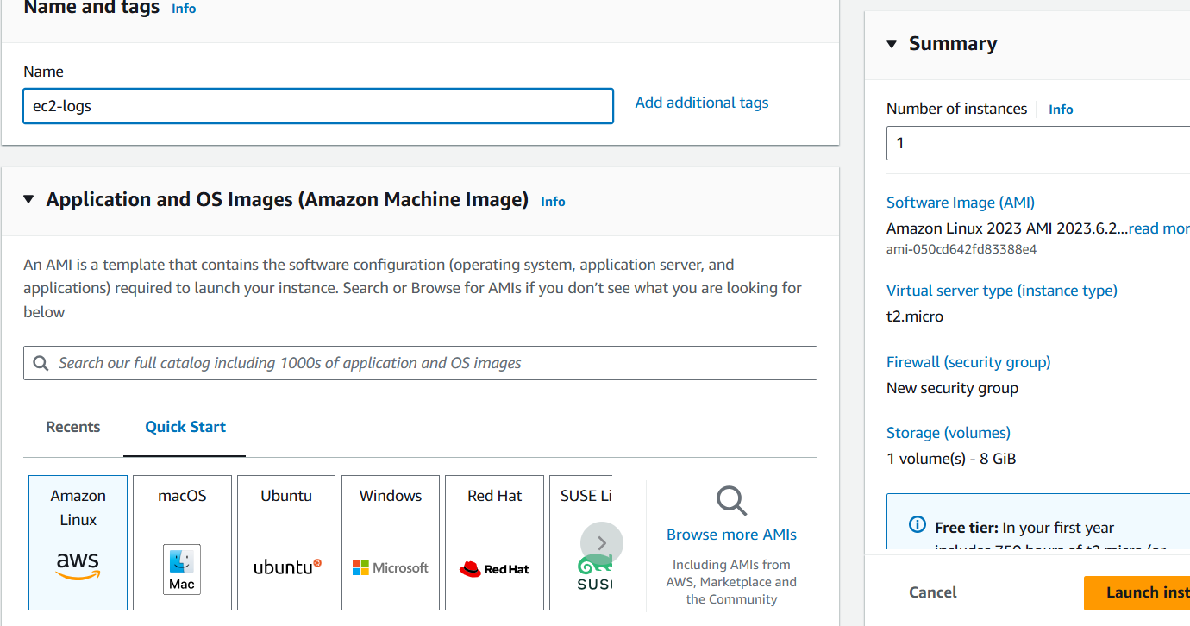

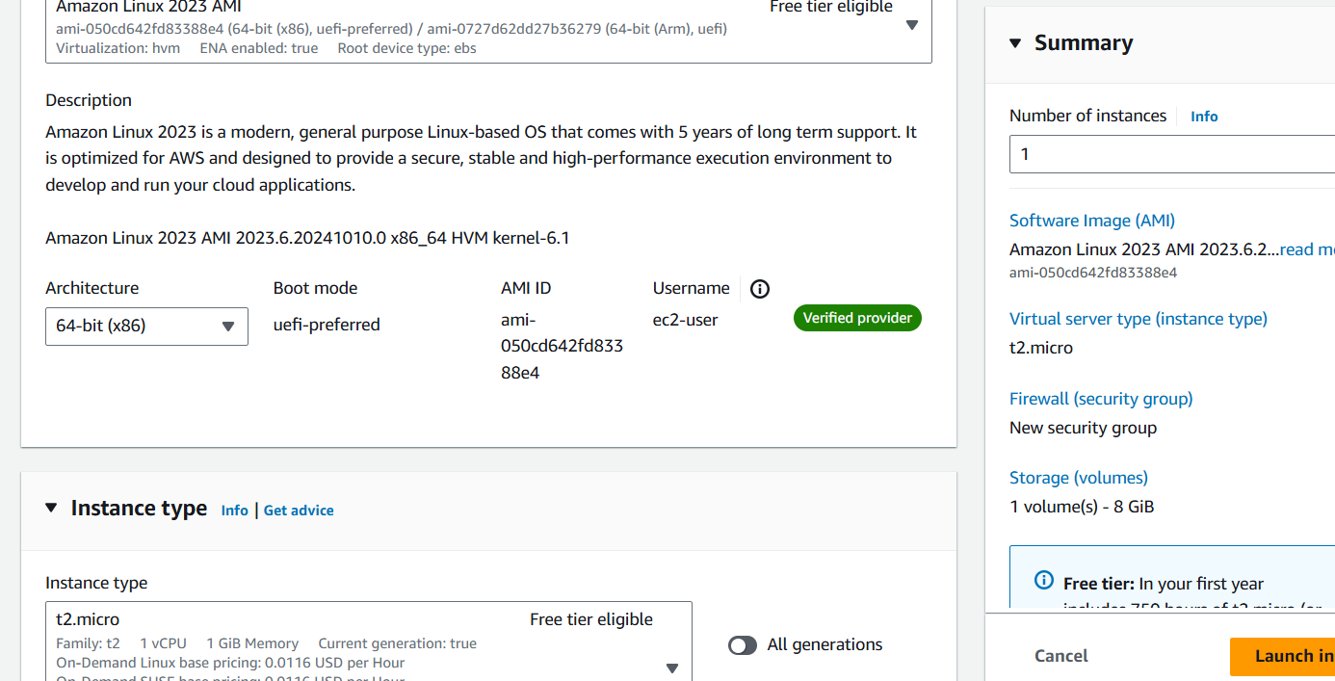

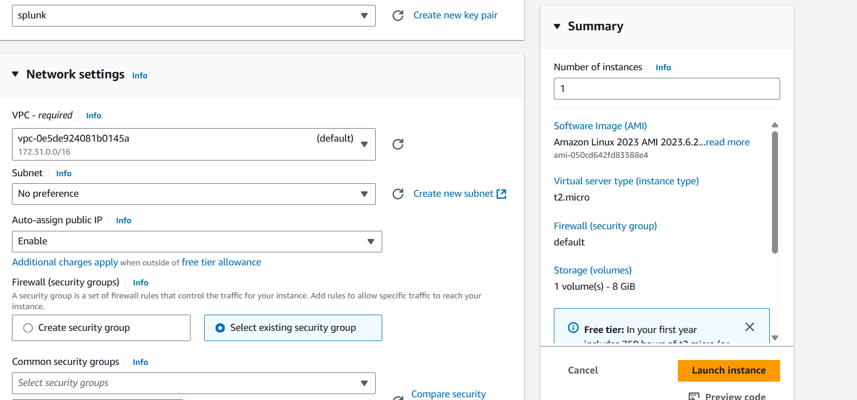

Click on Launch instance

Create IAM role for ec2 add administration access

* Open the instance
* Click on action

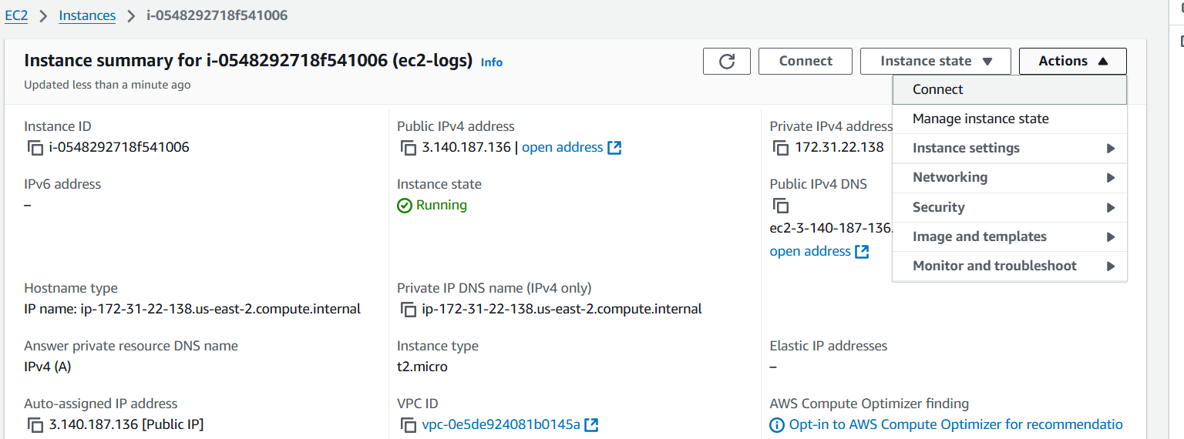

* click on security
* select Modify IAM role

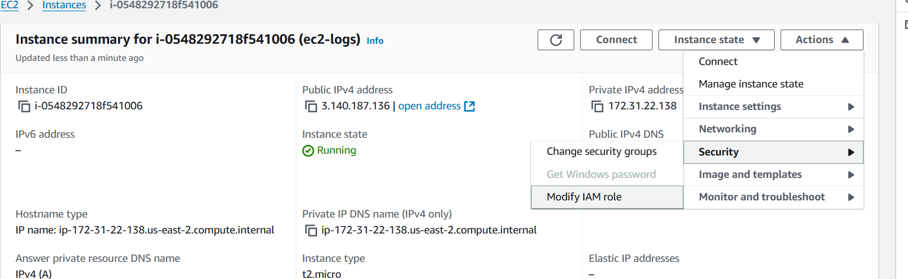

* add your IAM ROLE HERE
* thewn update iam role

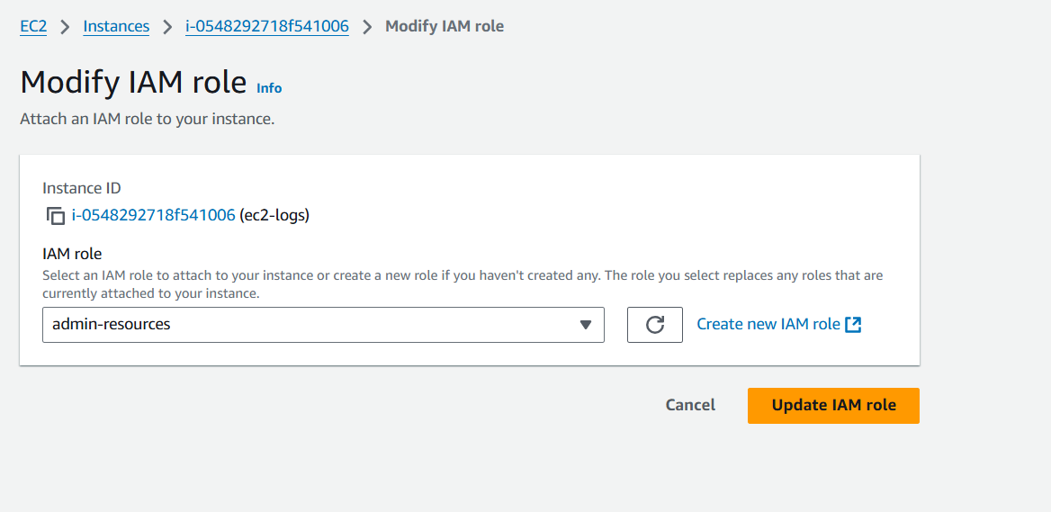

* connect to instam

* switch to root user

sudo su -

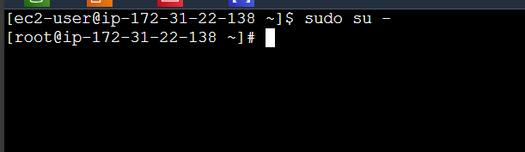

* install cloud watch agent

yum install amazon-cloudwatch-agent -y

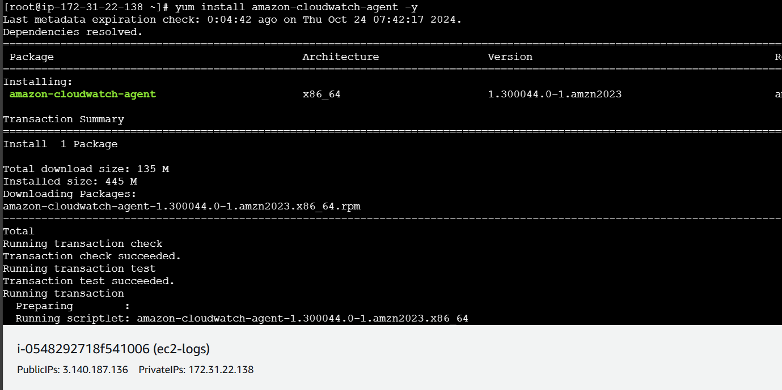

* set the configuration file amazon cloud watch agent
* use below command

sudo /opt/aws/amazon-cloudwatch-agent/bin/amazon-cloudwatch-agent-config-wizard

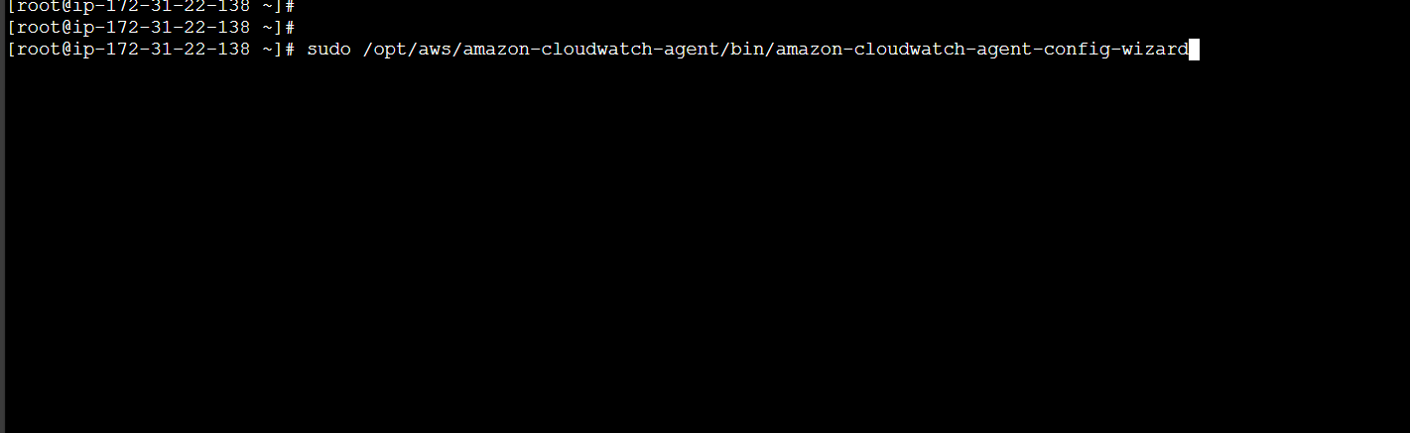

* Follow bellow process
* If we continues default option one just give enter
* Observe carefully

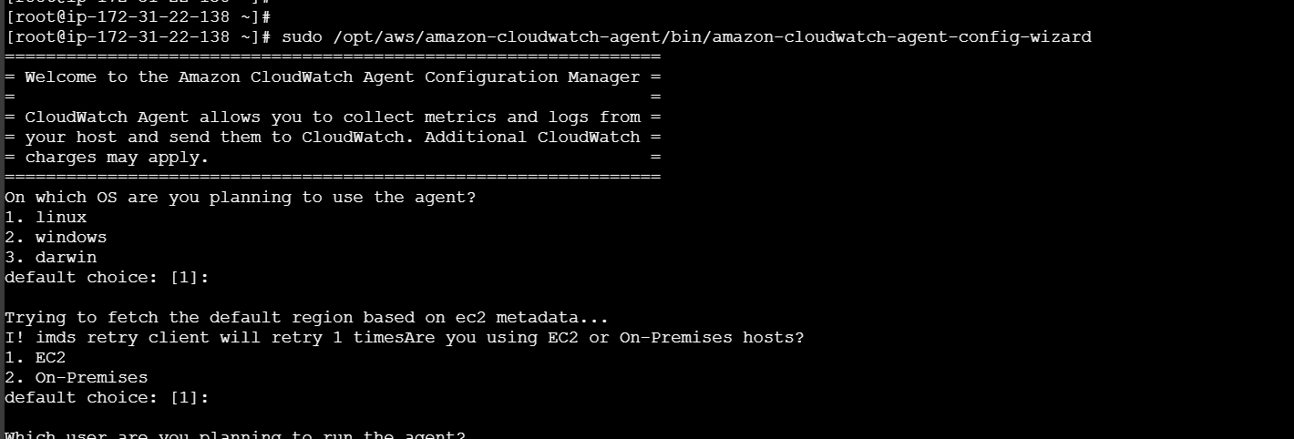

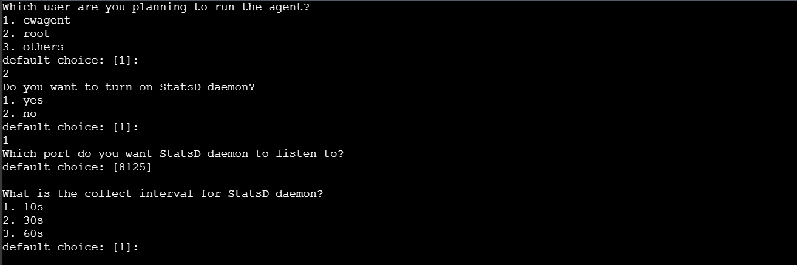

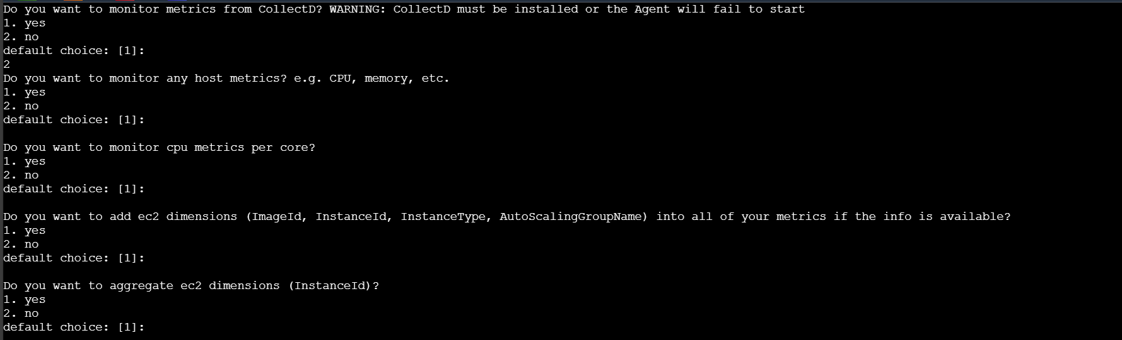

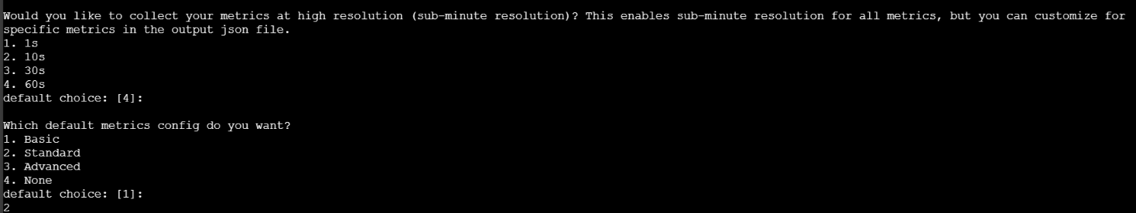

* You will get this type of Config json file out put

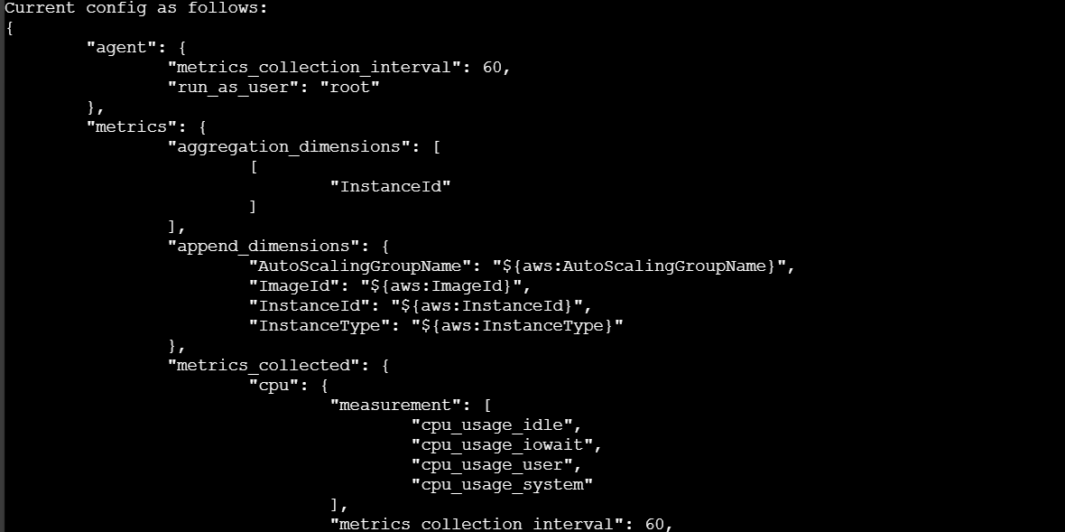

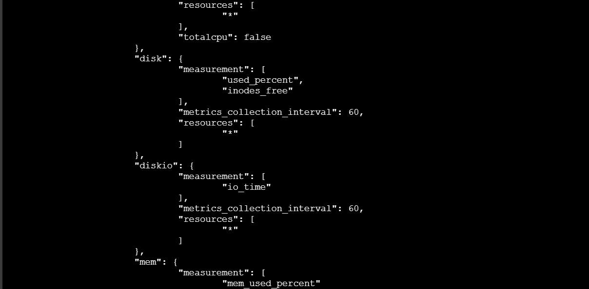

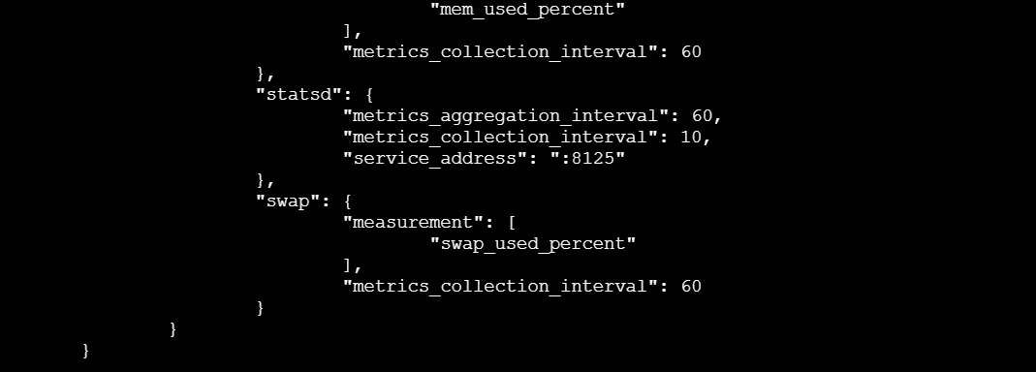

* Carefully enter log file path

/var/log/*

Above path will monitor entire ec2 logs

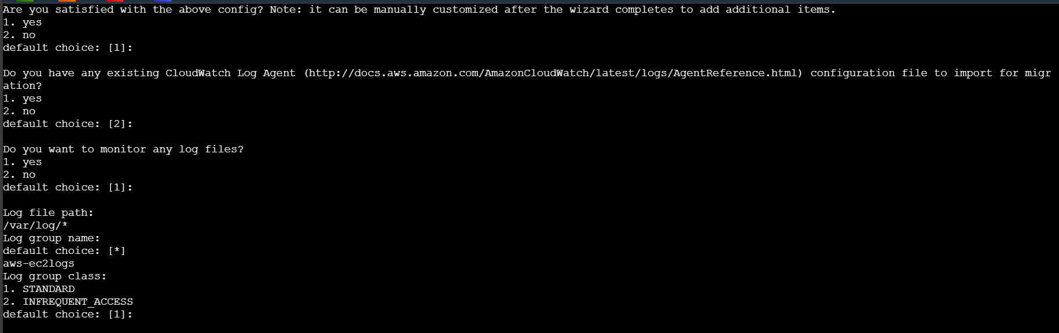

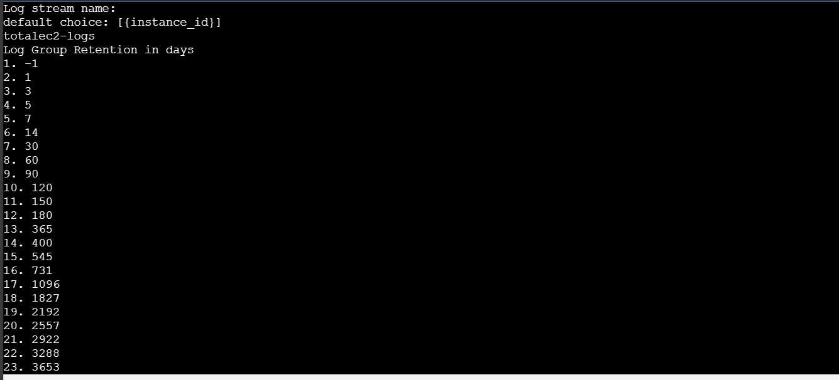

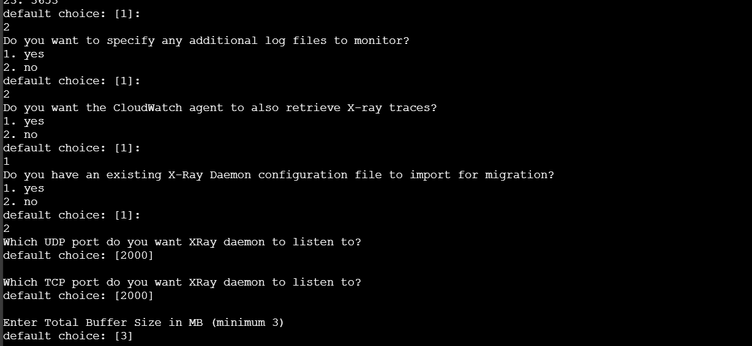

* After above process you will get Json output

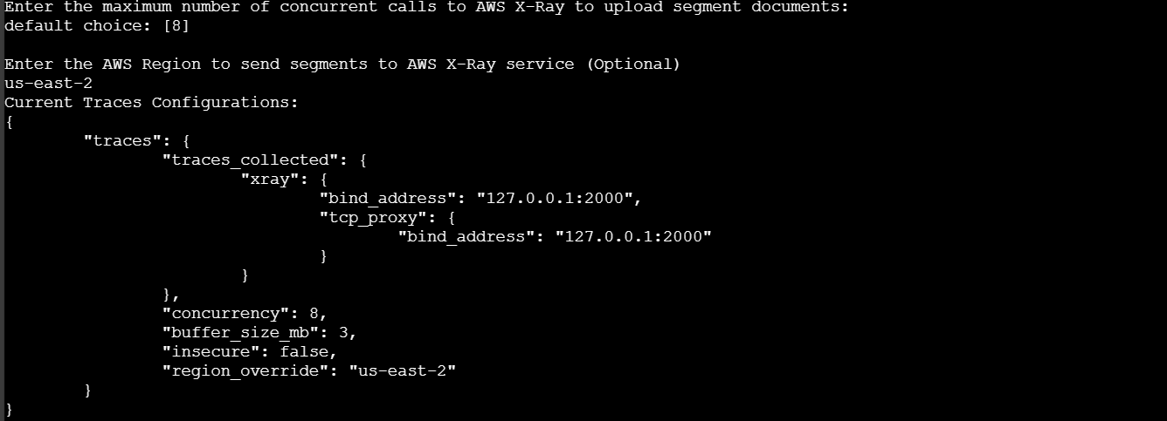

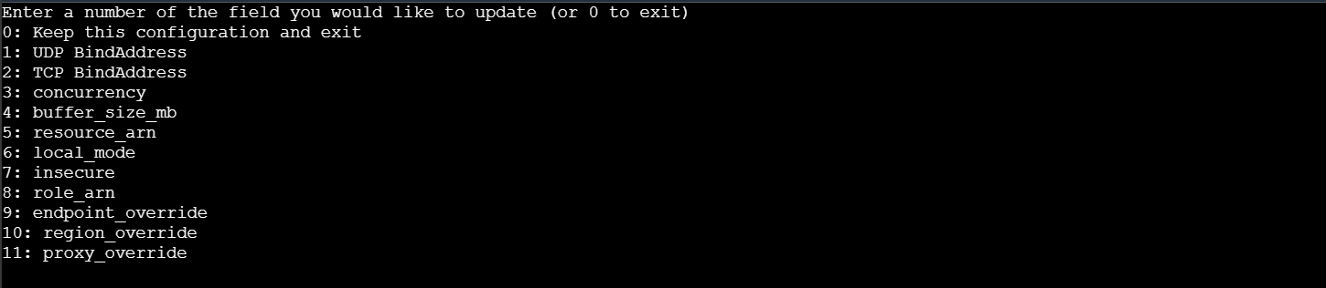

* This is final config json output

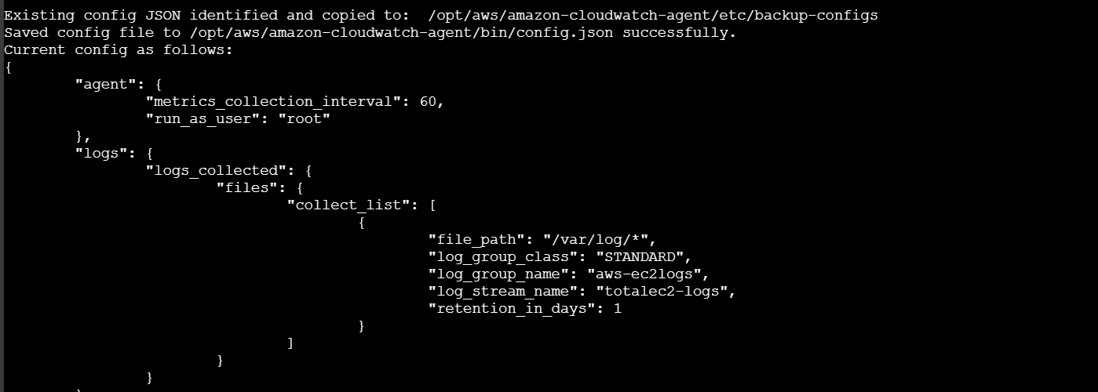

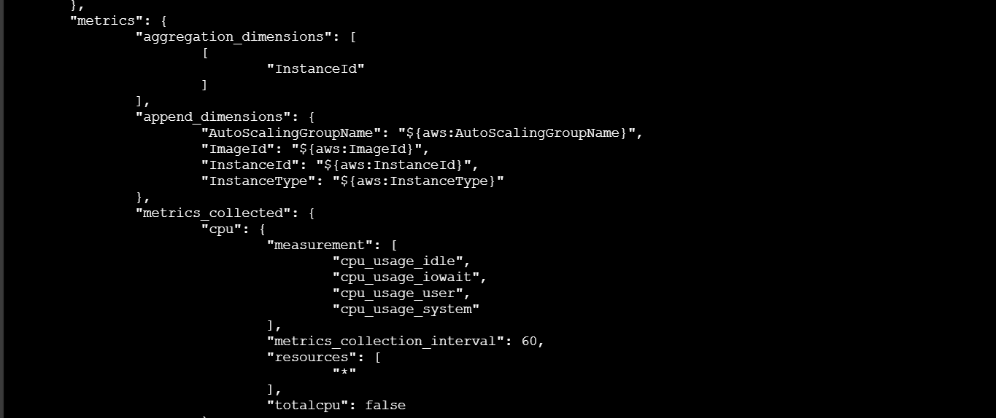

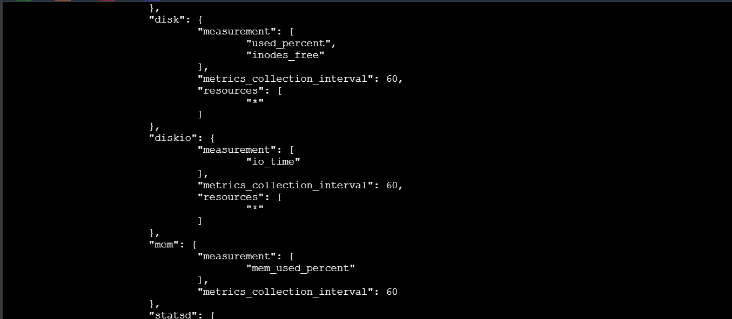

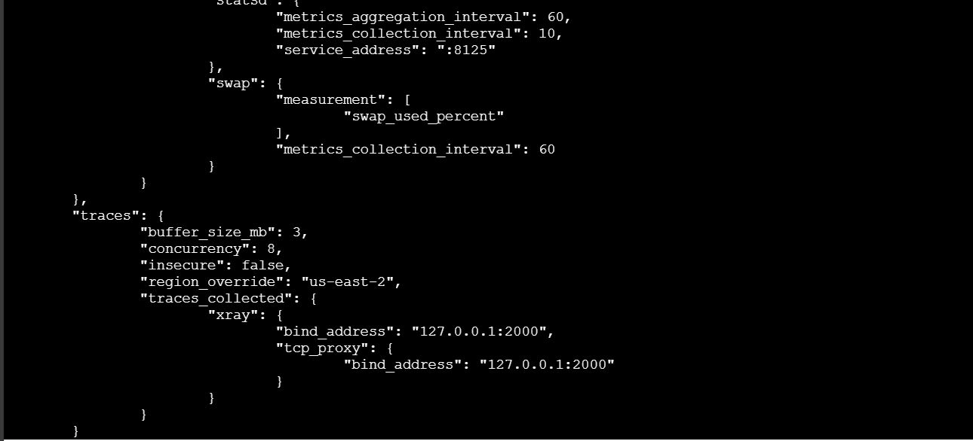

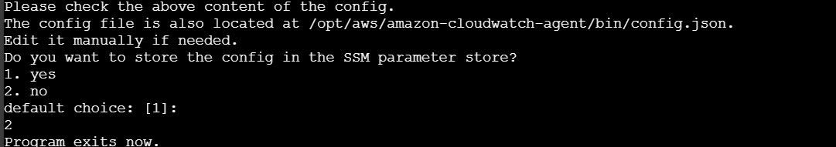

* Enter below command for strat the cloudwatch and creation of log group in cloud watch console based on config,json file

sudo /opt/aws/amazon-cloudwatch-agent/bin/amazon-cloudwatch-agent-ctl -a fetch-config -m ec2 -c file:/opt/aws/amazon-cloudwatch-agent/bin/config.json -s

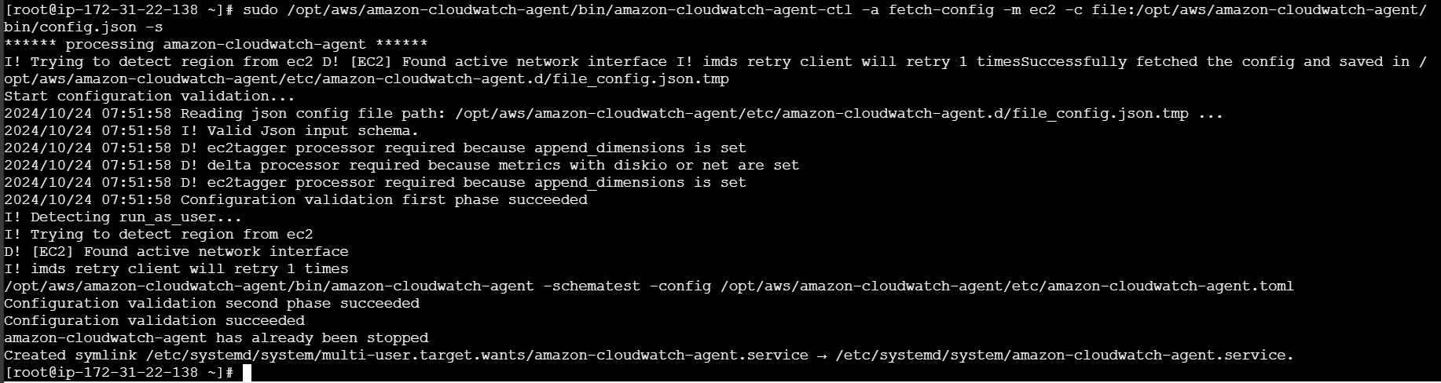

* Open your cloud watch console
* Check your log group created
* Open log group and check the logs

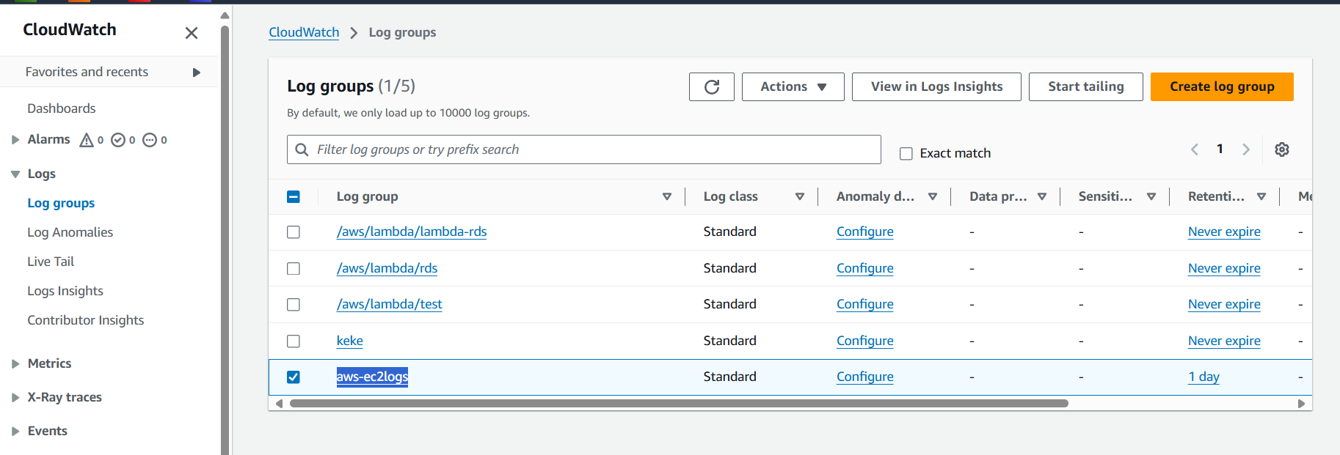

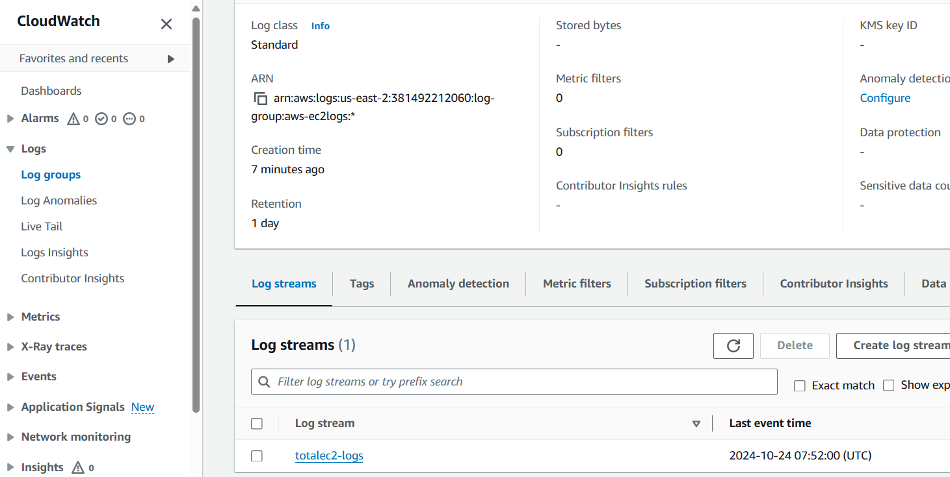

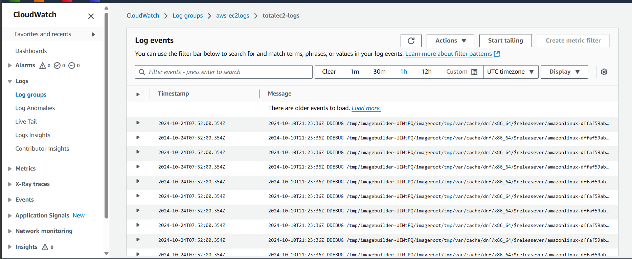

---------------------------------------------Thank You------------------------------------------------------------------

Method 2

* Launch the ec2
* Attach the iam role
* Connect to ec2
* Install cloud watch agent

yum install amazon-cloudwatch-agent -y

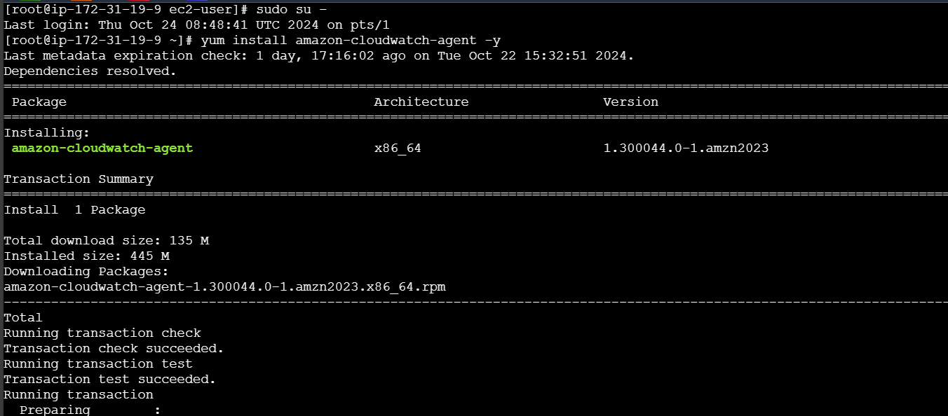

* Edit this file or create file using below commnd

vi /opt/aws/amazon-cloudwatch-agent/bin/config.json

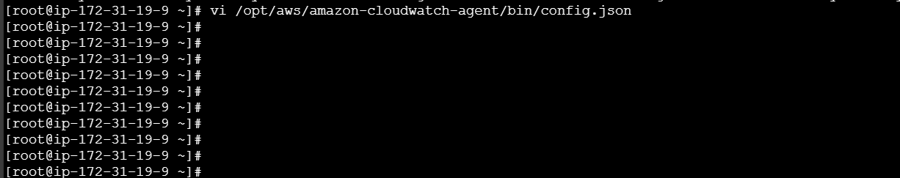

* Add below json config detailes
* Change the highlighted details based on your requirement

{

"agent": {

"metrics_collection_interval": 60,

"run_as_user": "root"

},

"logs": {

"logs_collected": {

"files": {

"collect_list": [

{

"file_path": "/var/log/*",

"log_group_class": "STANDARD",

"log_group_name": "aws",

"log_stream_name": "devops",

"retention_in_days": 1

}

]

}

}

},

"metrics": {

"aggregation_dimensions": [

[

"InstanceId"

]

],

"append_dimensions": {

"AutoScalingGroupName": "${aws:AutoScalingGroupName}",

"ImageId": "${aws:ImageId}",

"InstanceId": "${aws:InstanceId}",

"InstanceType": "${aws:InstanceType}"

},

"metrics_collected": {

"cpu": {

"measurement": [

"cpu_usage_idle",

"cpu_usage_iowait",

"cpu_usage_user",

"cpu_usage_system"

],

"metrics_collection_interval": 60,

"resources": [

"*"

],

"totalcpu": false

},

"disk": {

"measurement": [

"used_percent",

"inodes_free"

],

"metrics_collection_interval": 60,

"resources": [

"*"

]

},

"diskio": {

"measurement": [

"io_time"

],

"metrics_collection_interval": 60,

"resources": [

"*"

]

},

"mem": {

"measurement": [

"mem_used_percent"

],

"metrics_collection_interval": 60

},

"statsd": {

"metrics_aggregation_interval": 60,

"metrics_collection_interval": 10,

"service_address": ":8125"

},

"swap": {

"measurement": [

"swap_used_percent"

],

"metrics_collection_interval": 60

}

}

},

"traces": {

"buffer_size_mb": 3,

"concurrency": 8,

"insecure": false,

"region_override": "us-east-2",

"traces_collected": {

"xray": {

"bind_address": "127.0.0.1:2000",

"tcp_proxy": {

"bind_address": "127.0.0.1:2000"

}

}

}

}

}

* Enter below command for strat the cloudwatch and creation of log group in cloud watch console based on config,json file

sudo /opt/aws/amazon-cloudwatch-agent/bin/amazon-cloudwatch-agent-ctl -a fetch-config -m ec2 -c file:/opt/aws/amazon-cloudwatch-agent/bin/config.json -s

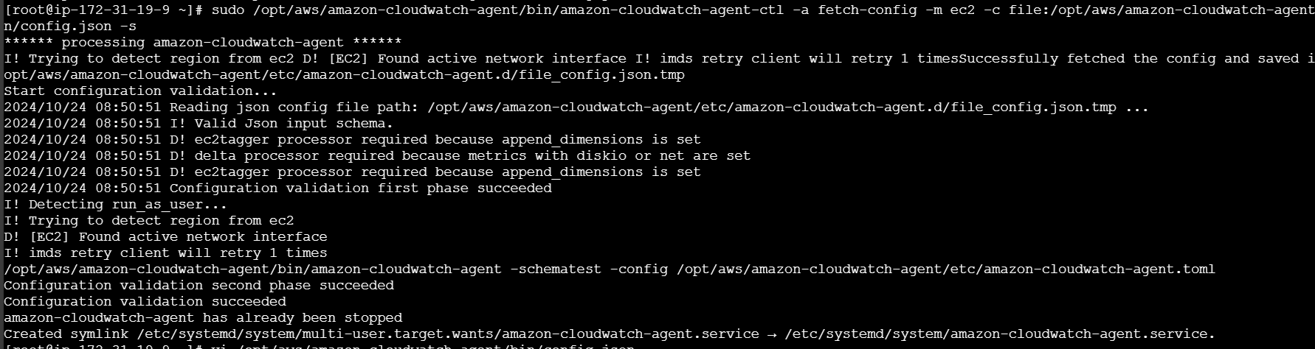

* Open your cloud watch and check

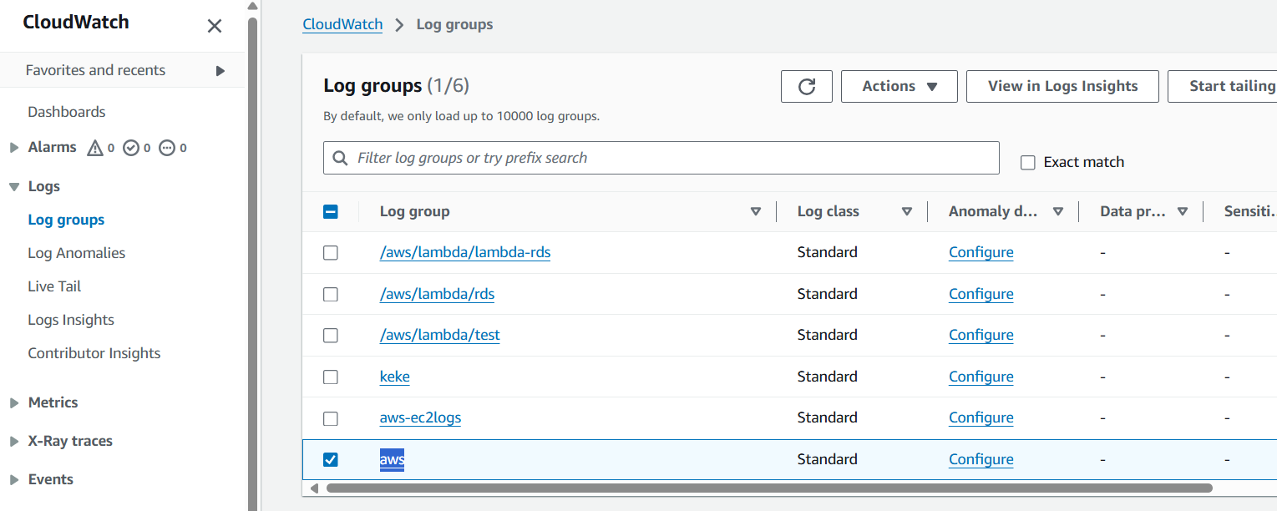

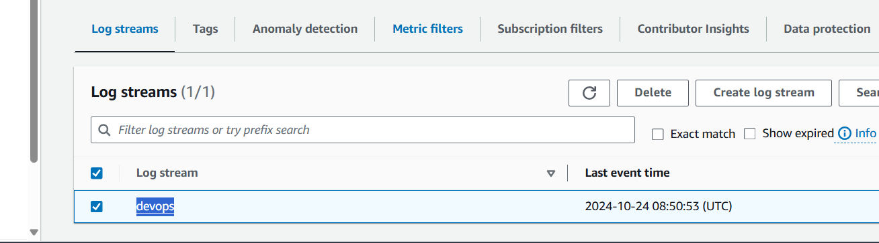

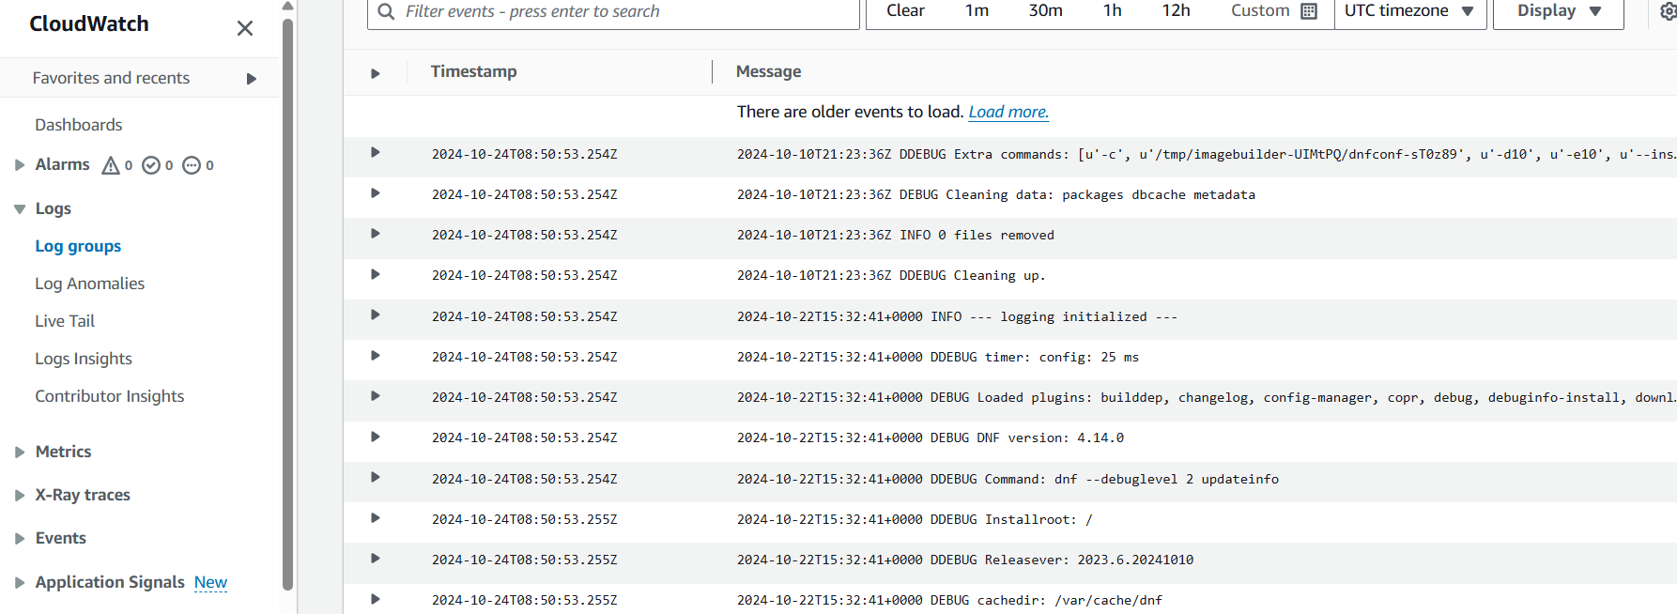

-----------------------------------------------------thank you ---------------------------------------------------------------